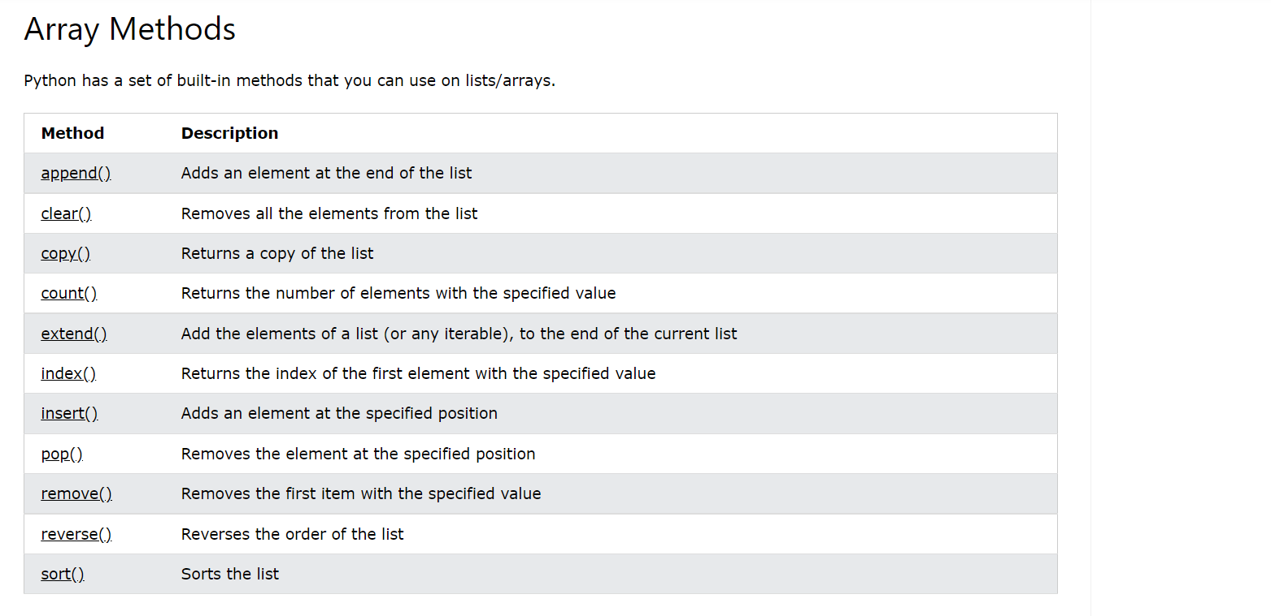

Python does not have built in arrays

Python list can be treated as array

**len( list_name )**

Gives the length of list

**del list_name**

deletes the array